| Cybersecurity |
| --- |
| 21.3 The Final Report |

Case Report

National Gallery DC

### Tracy’s iPhone [2012-07-15-National-Gallery]

# Table of Contents

Case Report

National Gallery DC

Tracy’s iPhone [2012-07-15-National-Gallery]

Table of Contents

Executive Summary

Equipment and Tools

Details of Tracy’s iPhone

Evidence to Establish Personas

Evidence relating to theft of valuable stamps

Evidence relating to defacement of museum art

Plot Timeline

Conclusion

Appendix A: Correspondence Evidence

Appendix B: WiFi and GPS Location Information

# Executive Summary

On January 21, 2016, Digitech Inc. was called in to assist the National Gallery, Washington D.C. (NGDC) case involving the conspiracy associated with the theft of valuable stamps and defacing of museums are at the NGDC.

* Tracy is a suspect in the aforementioned conspiracy.
* As part of the investigation, Tracy’s iPhone was taken into custody.
* Digitech, Inc. was tasked with investigating evidence relevant to the aforementioned conspiracy.

As described fully in the report, Digitech, Inc. made the following findings.

The given evidence below points to a plot devised by Tracy, her brother Pat, and a 3rd party to steal stamps from the National Gallery.

### Equipment and Tools

The Autopsy open-source forensics tool running within Kali Linux was used to analyze a bit-image of Tracy’s iPhone. Google Maps was used to locate GPS coordinates, Nano was the primary text editor employed during the investigation, and a native Kali Linux image viewer was used to view images.

# Details of Tracy’s iPhone

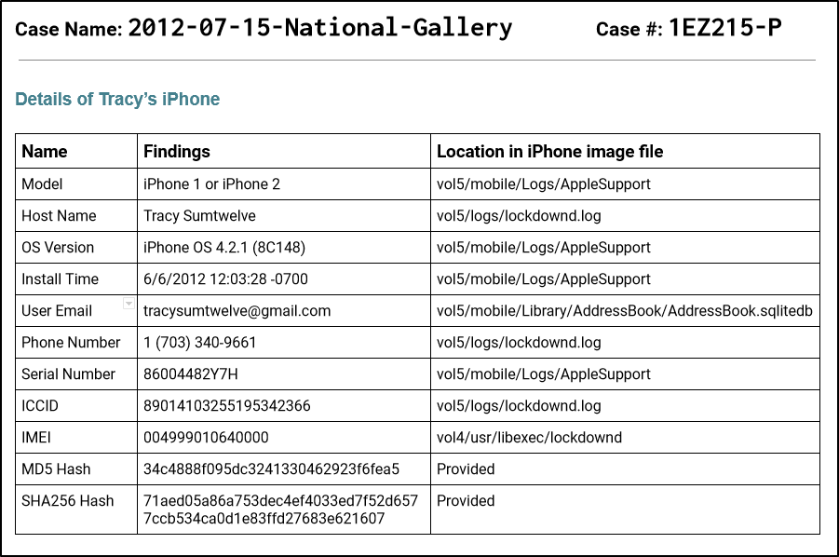

# Evidence to Establish Personas

This section establishes aliases, phone numbers, emails addresses associated with each person, and relationships between each individual.

Tracy:

Phone Number: (703) 340-9961

Personal Email: tracysumtwelve@gmail.com

Work Email: tracy.sumtwelve@nationalgallerydc.org

Relationship: Accused

Pat:

Phone Number: (571) 308-3236

Email: [patsumtwelve@gmail.com](mailto:patsumtwelve@gmail.com)

perrypatsum@yahoo.com

Relationship: Tracy’s Brother

Terry:

Phone Number: (703) 829-6071

Email:

Relationship: Daughter of Tracy and Joe

Joe:

Phone Number:

Email:

Relationship: Tracy’s Husband

Carry:

Phone Number: (202) 725-2124

Email:

Relationship: Friend of Tracy

Tracy appears to be losing a connection with her daughter (Terry) as she can no longer afford the private school Terry attends. Terry states she would rather live with her father (Joe). Tracy’s brother (Pat) is devoted to helping Tracy and uses connections with a known criminal (King). Carry is friends with Tracy and manipulates Tracy’s situation to force her into becoming an accomplice in this crime.

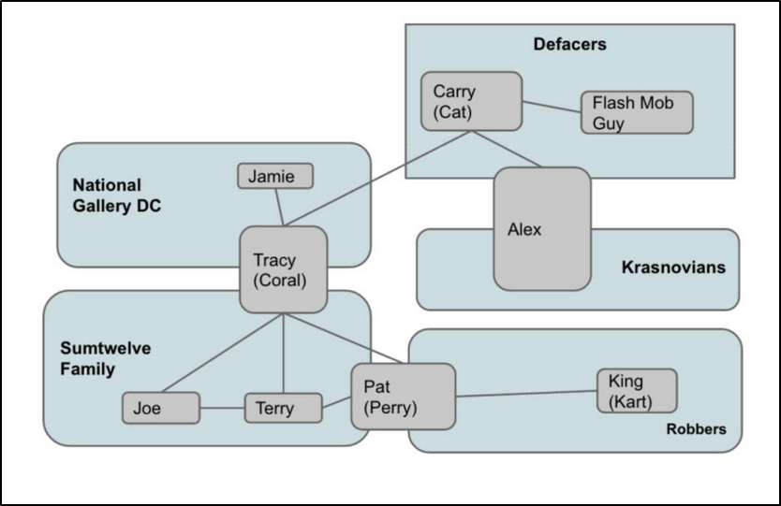

# Evidence relating to theft of valuable stamps

This sub-section provides details regarding the evidence found as it relates to the theft of valuable stamps.

Digitech was able to identify multiple emails and SMS messages between Tracy, Pat, Carry, and a co-conspirator named “King”. One email from “King” included an attachment titled ‘needs.txt’ that consisted of a list of items needed for the theft. See below image:

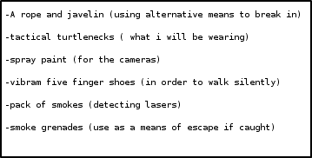

An MP3 audio file titled ‘Crazydave1.mp3’ was also located on the phone, but was unable to be played for further analysis.

An SMS message notifying Tracy that she had received a Target gift-card was also marked as evidence. The message instructed Tracy to visit a suspicious url and enter a numeric code. The website referenced in the message no longer exists, and seems to make use of ‘[www.target.com](http://www.target.com)’ as a subdomain, suggesting this was either a phishing attempt or somehow related to the theft.

Photo images of the stamps were located on the phone, alongside insurance documents covering the stamps. Examples of this can be seen directly below:

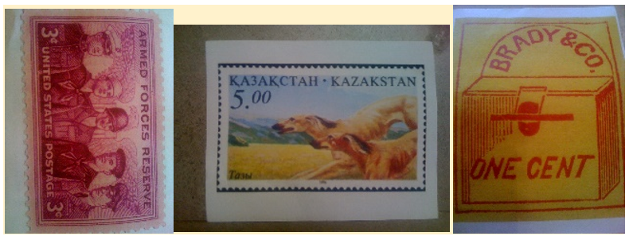

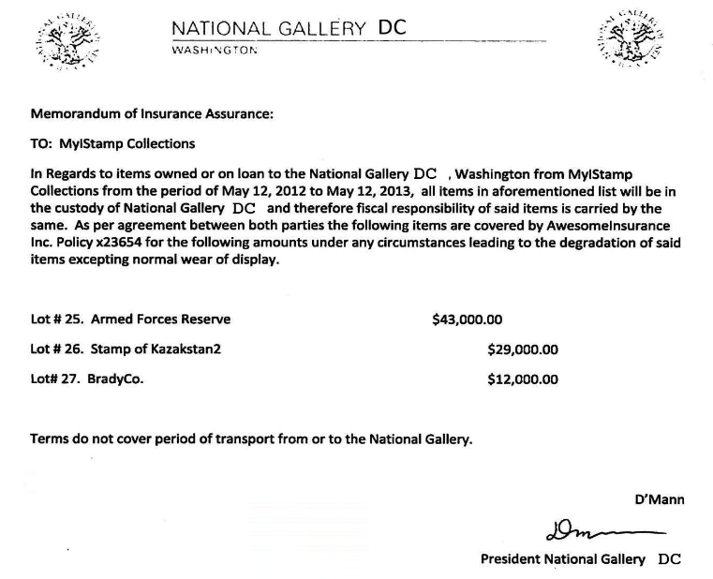

# Evidence relating to defacement of museum art

This sub-section provides details regarding the evidence found as it relates to the defacement of museum art.

Digitech was unable to identify any evidence within the iPhone that suggested the parties listed here were involved in defacement of museum art. All the evidence on the iPhone points to the theft of the stamps, most likely with intent to resell them. Defacing the stamps would decrease their potential value on the black market.

# Plot Timeline

* Tue, June 19 2012: Pat emailed Tracy with an MP3 audio recording.
* Thu, July 5 2012: PM Tracy and Carry agree via SMS to meet at Bubba’s Grill
* Fri, July 6 2012: Pat emails a ‘proposition’ to King, and forwards the correspondence to Tracy
* Fri, July 6 2012: Tracy and Carry confirm the meeting at Bubba’s via SMS
* Sat, July 7 2012: Tracy received an SMS from an unknown number that claimed she was the recipient of a Target Gift Card worth $1,000. The message instructs her to enter “703” at [www.target.com.trdt.biz](http://www.target.com.trdt.biz), however this URL is faked to appear associated with the Target Corporation. This is either a phishing scam, or perhaps related to the theft, but there is no solid evidence as to how the message relates.
* Mon, July 9 2012: Tracy sends herself an email describing which stamps to steal, and how much they are insured for
* Mon, July 9 2012: Pat and King discuss a list of needs that King requires to complete the job
* Tue, July 10 2012: Pat forwards the list of needs to Tracy
* Wed, July 11 2012: Carry and Tracy exchange SMS messages planning to meet
* Thu, July 12 2012: Tracy sends an SMS message to Carry to ask how the flashmob is going

# Conclusion

Evidence found on Tracy’s iPhone indicated the following:

* Both Tracy and Pat used alias to disguise their correspondence.
  + Pat made use of [patsumtwelve@gmail.com](mailto:patsumtwelve@gmail.com) instead of his usual address [perrypatsum@yahoo.com](mailto:perrypatsum@yahoo.com)
  + Tracy made use of [coralbluetwo@hotmail.com](mailto:coralbluetwo@hotmail.com) rather than her usual address [tracysumtwelve@gmail.com](mailto:tracysumtwelve@gmail.com)
* Pat was responsible for coordinating with a known criminal, “King”, at the address [throne1966@hotmail.com](mailto:throne1966@hotmail.com) and apparently leveraged a personal relationship with King’s parole officer as blackmail.
* Tracy coordinated with Carry to deliver a tablet with data pertaining to a flashmob that Carry intended to organize. This flashmob would act as a distraction for the museum’s security guards while King was stealing the stamps.
* Tracy sent herself documents related to the stamps and their insurance policies

# Appendix A: Correspondence Evidence

This subsection will provide an amalgamation of the email and SMS corresponce evidence.

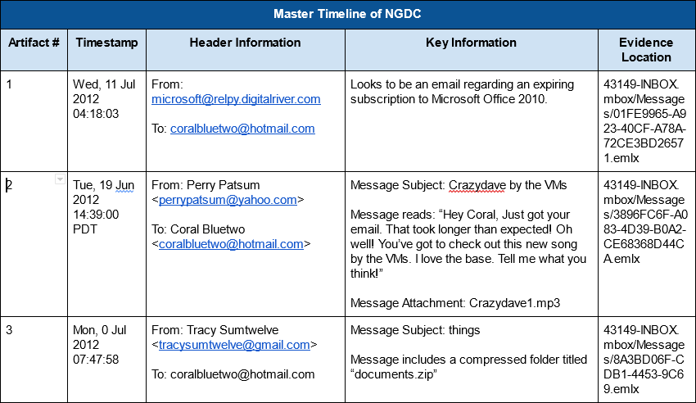

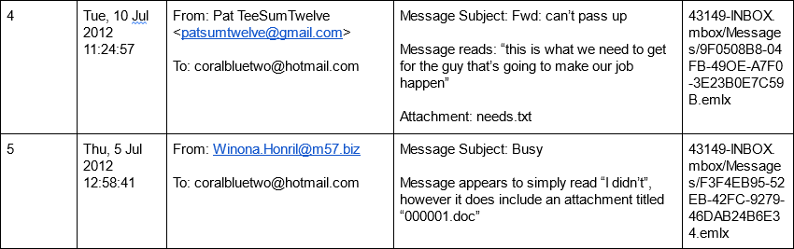

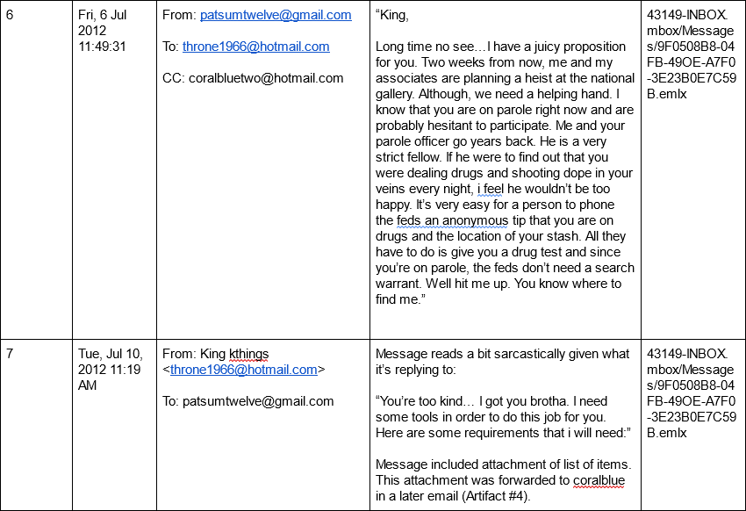

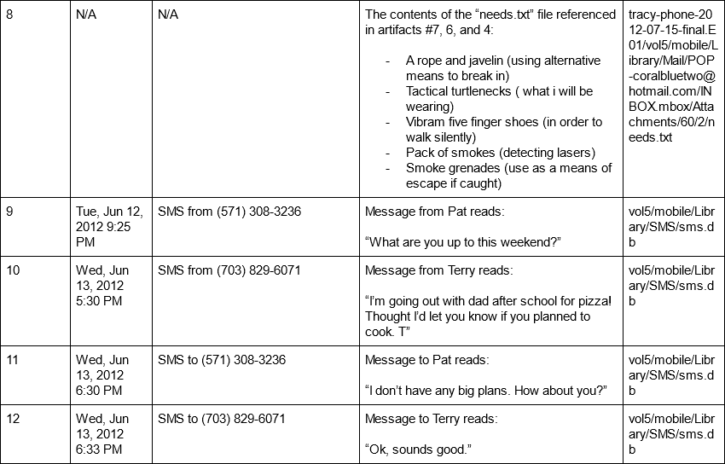

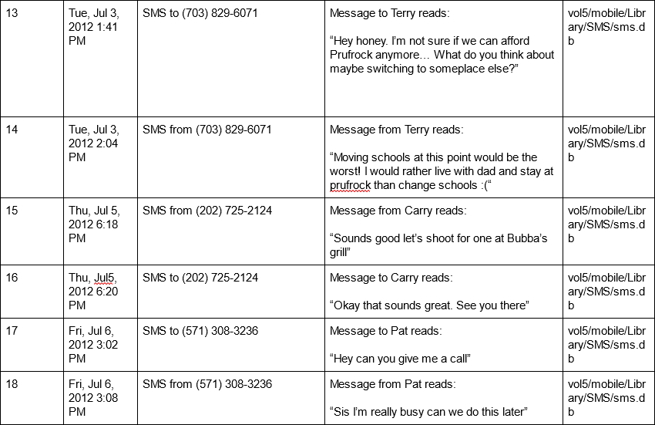

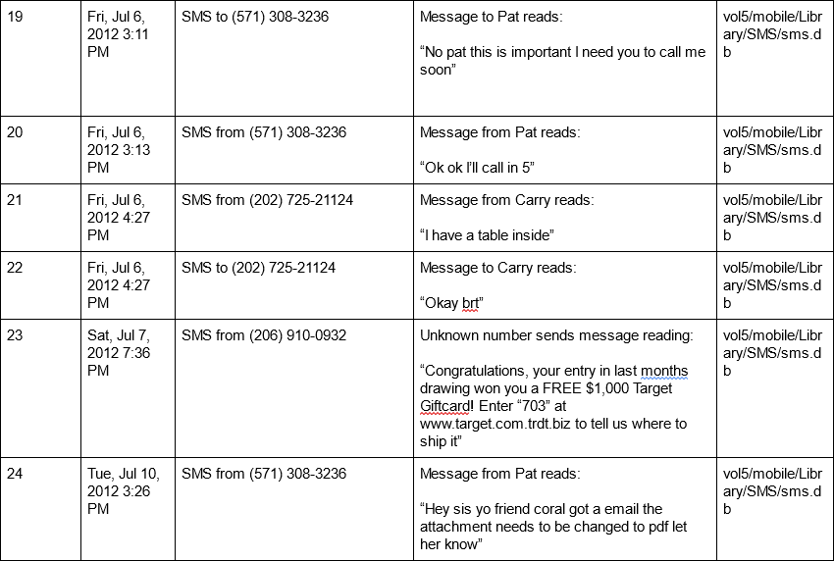

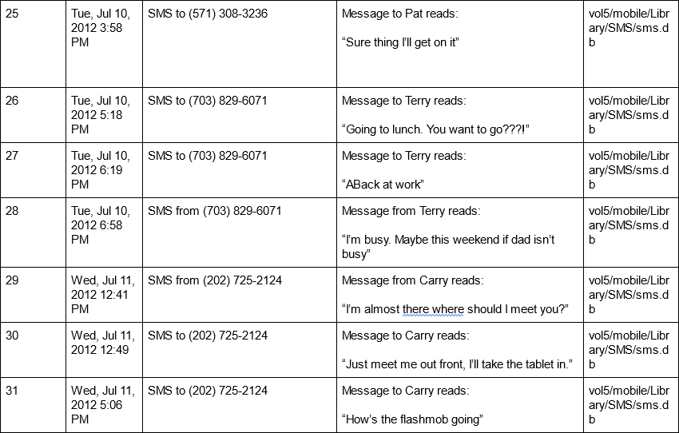

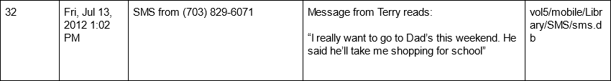

# Appendix B: WiFi and GPS Location Information

The following image plots WiFi and GPS Location Information gathered from Tracy’s iPhone. For every event in the table listed below, a pin has been placed on the map. Many of these pins overlap in area, and as each pin is numbered it is possible to determine a rough path of activity based on the final results. The later the phone was at the location, the higher the number on the pin.

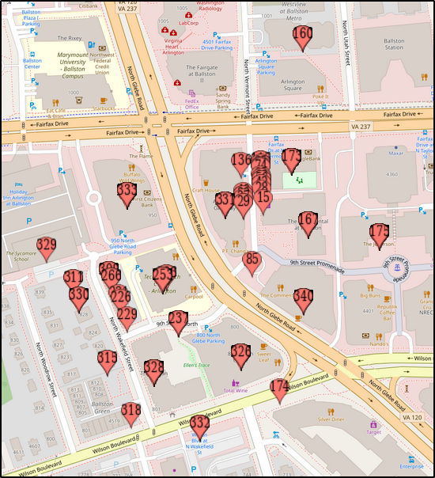

The unabridged WiFi information collected from Tracy’s iPhone:

| TableInfo  TableName SoftwareVersion SerialNumber  CompassCalibration 370.3 86004482Y7H  WifiLocation 370.3 86004482Y7H  Location 370.3 86004482Y7H  Wifi 370.3 86004482Y7H  Cell 370.3 86004482Y7H  CellLocation 370.3 86004482Y7H  CellLocationBoxes 370.3 86004482Y7H  CellLocationLocal 370.3 86004482Y7H  CellLocationLocalBoxes 370.3 86004482Y7H  CellLocationHarvest 370.3 86004482Y7H  WifiLocationHarvest 370.3 86004482Y7H  LocationHarvest 370.3 86004482Y7H  CompassCalibration  Timestamp MagneticX MagneticY MagneticZ BiasX BiasY BiasZ Level Magnitude Inclination  WifiLocation  MAC Timestamp Latitude Longitude HorizontalAccuracy Altitude VerticalAccuracy Speed Course Confidence  44:1e:a1:f4:d:7f 3.61306882473715E8 38.88055896 -77.11553561 281.0 96.0 19.0 -1.0 -1.0 50  0:23:5e:b0:6d:f1 3.61306882473715E8 38.88106083 -77.11533838 68.0 113.0 13.0 -1.0 -1.0 50  0:26:b8:ac:1c:10 3.61306882473715E8 38.88005346 -77.11595332 42.0 103.0 23.0 -1.0 -1.0 50  c0:c1:c0:15:66:fa 3.61306882473715E8 38.88093715 -77.11640596 42.0 134.0 9.0 -1.0 -1.0 50  e0:46:9a:3f:1b:a6 3.61306882473715E8 38.87996816 -77.11601394 42.0 104.0 38.0 -1.0 -1.0 50  54:75:d0:a5:f:a3 3.61306882473715E8 38.88138395 -77.11556851 48.0 133.0 43.0 -1.0 -1.0 50  54:75:d0:a5:f:a0 3.61306882473715E8 38.88139647 -77.11564362 42.0 111.0 31.0 -1.0 -1.0 50  0:26:b8:ad:bd:dc 3.61306882473715E8 38.87974703 -77.11598318 42.0 101.0 21.0 -1.0 -1.0 50  0:26:b8:ac:19:d0 3.61306882473715E8 38.87969022 -77.1154859 42.0 99.0 17.0 -1.0 -1.0 50  0:26:f3:f8:b8:fb 3.61306882473715E8 38.87970983 -77.11530274 42.0 101.0 18.0 -1.0 -1.0 50  0:26:f3:f8:b8:f8 3.61306882473715E8 38.87970793 -77.11529815 42.0 101.0 23.0 -1.0 -1.0 50  0:26:b8:ae:e7:1b 3.61306882473715E8 38.8796842 -77.11539471 42.0 101.0 20.0 -1.0 -1.0 50  0:26:f3:f8:b8:f9 3.61306882473715E8 38.87969332 -77.11530435 42.0 99.0 20.0 -1.0 -1.0 50  0:26:b8:ac:6:68 3.61306882473715E8 38.87969988 -77.11591041 42.0 96.0 16.0 -1.0 -1.0 50  0:24:6c:67:e8:a0 3.6130688701753E8 0.0 0.0 -1.0 0.0 -1.0 -1.0 -1.0 0  0:24:6c:67:e6:1 3.6130700024568E8 0.0 0.0 -1.0 0.0 -1.0 -1.0 -1.0 0  e4:e0:c5:f:29:fa 3.61307043743548E8 38.88143724 -77.11478394 45.0 140.0 25.0 -1.0 -1.0 50  0:18:1:fb:b2:c3 3.61307043743548E8 38.8815732 -77.11455619 88.0 138.0 45.0 -1.0 -1.0 50  0:18:f8:1a:69:23 3.61307043743548E8 38.88154673 -77.11469429 44.0 131.0 34.0 -1.0 -1.0 50  0:26:62:44:d5:4f 3.61307043743548E8 38.88157737 -77.11462634 43.0 130.0 35.0 -1.0 -1.0 50  c4:17:fe:0:65:d 3.61307043743548E8 38.88160669 -77.11448079 50.0 140.0 41.0 -1.0 -1.0 50  78:cd:8e:c:99:88 3.61307043743548E8 38.88160783 -77.11447507 61.0 138.0 38.0 -1.0 -1.0 50  0:23:97:eb:e8:d7 3.61307043743548E8 38.88157981 -77.11465042 62.0 132.0 36.0 -1.0 -1.0 50  10:9a:dd:83:92:13 3.61307043743548E8 38.88141357 -77.11484962 47.0 135.0 36.0 -1.0 -1.0 50  0:7f:28:1c:b4:20 3.61307043743548E8 38.88160395 -77.11459022 90.0 143.0 44.0 -1.0 -1.0 50  0:25:9c:e4:f9:55 3.61307043743548E8 38.88161092 -77.11455142 51.0 135.0 38.0 -1.0 -1.0 50  78:cd:8e:c:99:8a 3.61307043743548E8 38.88160616 -77.11439394 59.0 140.0 43.0 -1.0 -1.0 50  0:1f:90:dc:aa:dc 3.61307043743548E8 38.8816086 -77.11458355 91.0 145.0 44.0 -1.0 -1.0 50  0:18:f8:1b:16:d3 3.61307043743548E8 38.88145112 -77.11483669 63.0 125.0 33.0 -1.0 -1.0 50  0:1f:90:e8:ff:42 3.61307043743548E8 38.88152045 -77.11477804 50.0 137.0 29.0 -1.0 -1.0 50  10:9a:dd:86:b6:f1 3.61307043743548E8 38.88141649 -77.1148625 58.0 133.0 28.0 -1.0 -1.0 50  0:26:62:b5:3e:f4 3.61307043743548E8 38.88162308 -77.11441218 51.0 141.0 40.0 -1.0 -1.0 50  0:23:33:16:af:a0 3.61307043743548E8 38.8816142 -77.11435759 46.0 131.0 37.0 -1.0 -1.0 50  0:1f:90:b4:69:f8 3.61307043743548E8 38.88158559 -77.11470586 86.0 133.0 36.0 -1.0 -1.0 50  78:cd:8e:c:99:8b 3.61307043743548E8 38.88162446 -77.11437678 58.0 138.0 41.0 -1.0 -1.0 50  0:22:75:ef:19:5f 3.61307043743548E8 38.88147187 -77.11484867 57.0 127.0 30.0 -1.0 -1.0 50  0:26:b8:3b:63:48 3.61307043743548E8 38.88162553 -77.11436891 52.0 138.0 38.0 -1.0 -1.0 50  70:73:cb:b5:7b:df 3.61307043743548E8 38.88156569 -77.11475777 60.0 131.0 33.0 -1.0 -1.0 50  0:26:b8:17:a6:ae 3.61307043743548E8 38.88162535 -77.11435669 48.0 142.0 44.0 -1.0 -1.0 50  0:1e:4a:e5:17:23 3.61307043743548E8 38.88158553 -77.11473774 47.0 142.0 36.0 -1.0 -1.0 50  c8:4c:75:40:9e:49 3.61307043743548E8 38.88147741 -77.11486297 42.0 137.0 25.0 -1.0 -1.0 50  0:22:6b:64:bb:8e 3.61307043743548E8 38.88150566 -77.11485427 57.0 142.0 24.0 -1.0 -1.0 50  0:1f:90:d7:77:c0 3.61307043743548E8 38.8816508 -77.1143859 50.0 138.0 44.0 -1.0 -1.0 50  0:22:75:24:52:cc 3.61307043743548E8 38.88155686 -77.11480695 58.0 128.0 34.0 -1.0 -1.0 50  c4:3d:c7:ae:38:66 3.61307043743548E8 38.88164722 -77.11435991 49.0 134.0 41.0 -1.0 -1.0 50  78:cd:8e:c:99:89 3.61307043743548E8 38.88165903 -77.1144014 57.0 134.0 39.0 -1.0 -1.0 50  0:1f:90:ed:3c:2e 3.61307043743548E8 38.88144159 -77.1140722 81.0 132.0 46.0 -1.0 -1.0 50  84:db:2f:3:1c:64 3.61307043743548E8 38.88152474 -77.11412346 57.0 126.0 14.0 -1.0 -1.0 50  0:17:3f:83:cb:82 3.61307043743548E8 38.8816471 -77.11465734 72.0 126.0 32.0 -1.0 -1.0 50  0:26:62:e3:60:10 3.61307043743548E8 38.88166379 -77.11437833 52.0 140.0 44.0 -1.0 -1.0 50  0:1f:90:fb:9a:d0 3.61307043743548E8 38.88134002 -77.11402976 60.0 129.0 42.0 -1.0 -1.0 50  0:1e:4a:e5:17:24 3.61307043743548E8 38.88158988 -77.11480194 49.0 140.0 35.0 -1.0 -1.0 50  90:27:e4:5c:d1:8b 3.61307043743548E8 38.88168364 -77.11445981 53.0 130.0 35.0 -1.0 -1.0 50  0:18:18:ff:7d:8b 3.61307043743548E8 38.88151955 -77.11488258 42.0 135.0 31.0 -1.0 -1.0 50  e0:91:f5:ec:6c:23 3.61307043743548E8 38.88135969 -77.11402219 138.0 134.0 31.0 -1.0 -1.0 50  0:26:b8:af:de:1d 3.61307043743548E8 38.88166946 -77.11463308 52.0 128.0 33.0 -1.0 -1.0 50  84:db:2f:3:23:49 3.61307043743548E8 38.88156437 -77.11413609 64.0 136.0 36.0 -1.0 -1.0 50  0:1e:4a:e5:17:20 3.61307043743548E8 38.88159155 -77.11481052 50.0 138.0 33.0 -1.0 -1.0 50  68:7f:74:94:aa:ec 3.61307043743548E8 38.88133502 -77.11400651 59.0 132.0 35.0 -1.0 -1.0 50  0:7f:28:a:c5:c4 3.61307043743548E8 38.88169968 -77.11453354 57.0 135.0 38.0 -1.0 -1.0 50  68:7f:74:94:aa:ed 3.61307043743548E8 38.88133615 -77.11399537 58.0 132.0 37.0 -1.0 -1.0 50  0:1f:90:e9:76:b 3.61307043743548E8 38.88168793 -77.11464738 72.0 140.0 33.0 -1.0 -1.0 50  0:26:62:b7:3e:e 3.61307043743548E8 38.88148528 -77.11403554 62.0 133.0 40.0 -1.0 -1.0 50  0:26:b8:5e:fc:72 3.61307043743548E8 38.88164049 -77.11420023 84.0 139.0 48.0 -1.0 -1.0 50  0:26:b8:5e:81:e4 3.61307043743548E8 38.88161075 -77.11483067 56.0 129.0 35.0 -1.0 -1.0 50  0:7f:28:2b:b6:95 3.61307043743548E8 38.88140171 -77.1139853 86.0 124.0 42.0 -1.0 -1.0 50  0:1f:90:f0:54:da 3.61307043743548E8 38.88163012 -77.11481797 52.0 125.0 30.0 -1.0 -1.0 50  0:26:b8:af:1b:c5 3.61307043743548E8 38.88169914 -77.11429029 54.0 134.0 36.0 -1.0 -1.0 50  88:43:e1:d7:84:50 3.61307043743548E8 38.88172066 -77.11435794 67.0 129.0 35.0 -1.0 -1.0 50  0:1f:90:eb:8c:3b 3.61307043743548E8 38.88173264 -77.11441981 92.0 139.0 42.0 -1.0 -1.0 50  0:26:62:ce:5c:ea 3.61307043743548E8 38.88169705 -77.11425167 56.0 135.0 42.0 -1.0 -1.0 50  0:1f:f3:f4:91:bb 3.61307043743548E8 38.88170504 -77.11426556 53.0 141.0 45.0 -1.0 -1.0 50  0:18:1:f5:30:ba 3.61307043743548E8 38.88172852 -77.1143319 58.0 141.0 41.0 -1.0 -1.0 50  0:7f:28:11:90:c6 3.61307043743548E8 38.88171833 -77.11428588 54.0 136.0 38.0 -1.0 -1.0 50  0:7f:28:2a:69:27 3.61307043743548E8 38.88175261 -77.11455583 79.0 129.0 40.0 -1.0 -1.0 50  0:22:75:4c:57:79 3.61307043743548E8 38.88170462 -77.11475878 56.0 121.0 28.0 -1.0 -1.0 50  0:90:4b:75:ec:4b 3.61307043743548E8 38.88122379 -77.11393213 76.0 134.0 41.0 -1.0 -1.0 50  0:26:b8:33:86:18 3.61307043743548E8 38.88132381 -77.11391836 52.0 132.0 35.0 -1.0 -1.0 50  0:1f:90:cb:cb:e8 3.61307043743548E8 38.88137209 -77.11391937 52.0 139.0 32.0 -1.0 -1.0 50  d8:30:62:33:5:33 3.61307043743548E8 38.88175648 -77.11436641 71.0 131.0 41.0 -1.0 -1.0 50  0:26:62:a1:8f:e4 3.61307043743548E8 38.88150703 -77.11396539 70.0 136.0 52.0 -1.0 -1.0 50  0:1f:90:dc:66:18 3.61307043743548E8 38.88156968 -77.11400794 57.0 118.0 29.0 -1.0 -1.0 50  0:1f:90:e8:ff:4c 3.61307043743548E8 38.88176977 -77.11453813 77.0 122.0 33.0 -1.0 -1.0 50  0:26:62:dc:63:b8 3.61307043743548E8 38.88171607 -77.11478084 49.0 127.0 33.0 -1.0 -1.0 50  68:7f:74:66:2c:f6 3.61307043743548E8 38.88134866 -77.11390244 63.0 133.0 36.0 -1.0 -1.0 50  0:1f:90:fa:40:3c 3.61307043743548E8 38.88096624 -77.11487352 61.0 133.0 41.0 -1.0 -1.0 50  0:1f:90:f0:5b:e7 3.61307043743548E8 38.88156688 -77.11398798 58.0 118.0 31.0 -1.0 -1.0 50  e0:46:9a:3c:a3:a4 3.61307043743548E8 38.8813371 -77.11389219 56.0 130.0 32.0 -1.0 -1.0 50  68:7f:74:78:ec:fa 3.61307043743548E8 38.88147109 -77.11392492 58.0 128.0 34.0 -1.0 -1.0 50  0:7f:28:32:2f:42 3.61307043743548E8 38.88123995 -77.11389786 74.0 129.0 34.0 -1.0 -1.0 50  0:1f:90:be:1:f8 3.61307043743548E8 38.88177251 -77.11434 59.0 142.0 45.0 -1.0 -1.0 50  0:1f:90:e1:c9:f2 3.61307043743548E8 38.88135164 -77.11388808 57.0 133.0 34.0 -1.0 -1.0 50  0:1f:f3:f4:d3:b9 3.61307043743548E8 38.88178312 -77.11439216 78.0 189.0 78.0 -1.0 -1.0 50  0:1f:90:e0:4e:1e 3.61307043743548E8 38.8817653 -77.11429858 56.0 144.0 48.0 -1.0 -1.0 50  0:26:62:ce:4f:2b 3.61307043743548E8 38.88178908 -77.11455655 84.0 143.0 40.0 -1.0 -1.0 50  0:26:62:e2:3:14 3.61307043743548E8 38.88173216 -77.11478519 68.0 121.0 35.0 -1.0 -1.0 50  90:84:d:ee:50:29 3.61307043743548E8 38.8817141 -77.11482745 58.0 108.0 42.0 -1.0 -1.0 50  0:1f:90:e4:80:5 3.61307043743548E8 38.88150262 -77.11392742 59.0 134.0 34.0 -1.0 -1.0 50  94:44:52:69:e4:eb 3.61307043743548E8 38.88161849 -77.11496579 44.0 111.0 15.0 -1.0 -1.0 50  0:19:e3:fa:ba:94 3.61307043743548E8 38.8813827 -77.11388021 61.0 132.0 39.0 -1.0 -1.0 50  0:26:62:ca:5d:7b 3.61307043743548E8 38.88155156 -77.11395156 66.0 139.0 41.0 -1.0 -1.0 50  0:26:62:e1:7b:fc 3.61307043743548E8 38.88178151 -77.11467546 92.0 135.0 48.0 -1.0 -1.0 50  0:26:62:72:49:d9 3.61307043743548E8 38.88159388 -77.11397725 94.0 132.0 21.0 -1.0 -1.0 50  74:44:1:45:9c:e4 3.61307043743548E8 38.88122731 -77.11387401 81.0 130.0 31.0 -1.0 -1.0 50  0:14:bf:2a:a2:b9 3.61307043743548E8 38.88178282 -77.11427974 64.0 125.0 34.0 -1.0 -1.0 50  98:fc:11:94:68:7d 3.61307043743548E8 38.88130271 -77.11385822 55.0 136.0 38.0 -1.0 -1.0 50  0:1a:70:78:f7:49 3.61307043743548E8 38.88175958 -77.11477959 62.0 126.0 38.0 -1.0 -1.0 50  0:1f:33:df:90:52 3.61307043743548E8 38.88181424 -77.11449939 80.0 133.0 48.0 -1.0 -1.0 50  0:15:ff:15:a2:1e 3.61307043743548E8 38.88181304 -77.11444294 116.0 121.0 47.0 -1.0 -1.0 50  0:7f:28:30:3:2b 3.61307043743548E8 38.88119298 -77.11387157 72.0 135.0 43.0 -1.0 -1.0 50  0:1e:e5:62:96:e2 3.61307043743548E8 38.88157325 -77.11394077 61.0 130.0 33.0 -1.0 -1.0 50  0:23:69:54:38:4b 3.61307043743548E8 38.88172227 -77.11411029 57.0 135.0 25.0 -1.0 -1.0 50  0:1f:90:d0:65:0 3.61307043743548E8 38.8814342 -77.1138646 63.0 134.0 41.0 -1.0 -1.0 50  0:7f:28:b9:6d:27 3.61307043743548E8 38.88168627 -77.11404871 66.0 120.0 30.0 -1.0 -1.0 50  0:21:0:69:a3:6c 3.61307043743548E8 38.88143491 -77.11385905 54.0 139.0 30.0 -1.0 -1.0 50  0:26:62:ce:4e:38 3.61307043743548E8 38.88176161 -77.11480307 62.0 123.0 34.0 -1.0 -1.0 50  c:85:25:c7:b6:d0 3.61307043743548E8 38.88166457 -77.11401653 51.0 127.0 32.0 -1.0 -1.0 50  c0:c1:c0:1b:ff:e5 3.61307043743548E8 38.88175243 -77.11414945 54.0 126.0 31.0 -1.0 -1.0 50  d0:df:c7:c6:51:e8 3.61307043743548E8 38.88151884 -77.11389046 58.0 135.0 34.0 -1.0 -1.0 50  0:1f:90:f5:d3:fc 3.61307043743548E8 38.88147419 -77.11386793 64.0 134.0 38.0 -1.0 -1.0 50  0:26:b8:17:4e:43 3.61307043743548E8 38.88125324 -77.11384046 52.0 131.0 36.0 -1.0 -1.0 50  0:26:b8:44:88:5f 3.61307043743548E8 38.88108551 -77.11390584 51.0 146.0 41.0 -1.0 -1.0 50  0:26:62:61:5a:a9 3.61307043743548E8 38.88127672 -77.11382895 51.0 125.0 41.0 -1.0 -1.0 50  30:46:9a:95:d5:ca 3.61307043743548E8 38.88183361 -77.11441653 82.0 145.0 43.0 -1.0 -1.0 50  0:25:9c:32:5:2c 3.61307043743548E8 38.88126099 -77.11382877 52.0 141.0 31.0 -1.0 -1.0 50  0:1f:90:c5:80:9c 3.61307043743548E8 38.88164103 -77.11396831 124.0 132.0 38.0 -1.0 -1.0 50  0:15:62:ff:e0:db 3.61307043743548E8 38.88163256 -77.11502194 46.0 120.0 17.0 -1.0 -1.0 50  0:1f:90:ce:7a:1c 3.61307043743548E8 38.8817898 -77.11420184 56.0 132.0 36.0 -1.0 -1.0 50  0:26:b8:31:2e:3 3.61307043743548E8 38.8817805 -77.11480861 50.0 123.0 31.0 -1.0 -1.0 50  0:1f:90:fe:d8:40 3.61307043743548E8 38.88163006 -77.11394703 62.0 127.0 38.0 -1.0 -1.0 50  0:26:b8:98:7a:42 3.61307043743548E8 38.88184547 -77.11447155 66.0 120.0 45.0 -1.0 -1.0 50  0:1f:90:f7:5a:14 3.61307043743548E8 38.88124471 -77.11381757 43.0 139.0 30.0 -1.0 -1.0 50  0:1f:90:e0:4f:e3 3.61307043743548E8 38.88182967 -77.11431092 53.0 137.0 40.0 -1.0 -1.0 50  0:18:39:46:d0:ba 3.61307043743548E8 38.88175499 -77.1148808 60.0 128.0 36.0 -1.0 -1.0 50  0:26:62:df:df:51 3.61307043743548E8 38.88148957 -77.11383688 92.0 134.0 29.0 -1.0 -1.0 50  0:26:62:9f:6e:71 3.61307043743548E8 38.88126087 -77.11380231 42.0 137.0 31.0 -1.0 -1.0 50  0:1e:8c:62:1:e4 3.61307043743548E8 38.88123255 -77.11380374 42.0 138.0 27.0 -1.0 -1.0 50  0:26:62:86:25:dc 3.61307043743548E8 38.88185477 -77.11459583 64.0 125.0 35.0 -1.0 -1.0 50  c:85:25:c7:b6:d2 3.61307043743548E8 38.88170075 -77.11399596 50.0 122.0 35.0 -1.0 -1.0 50  0:26:62:f1:92:cc 3.61307043743548E8 38.88184446 -77.11469066 81.0 120.0 32.0 -1.0 -1.0 50  30:46:9a:95:c1:f0 3.61307043743548E8 38.88157057 -77.11386483 60.0 130.0 38.0 -1.0 -1.0 50  c:85:25:c7:b6:d1 3.61307043743548E8 38.88171738 -77.11400479 48.0 126.0 39.0 -1.0 -1.0 50  b8:c7:5d:c:5c:59 3.61307043743548E8 38.88180202 -77.11415374 55.0 123.0 34.0 -1.0 -1.0 50  84:db:2f:2:cb:5e 3.61307043743548E8 38.88185441 -77.11431825 70.0 169.0 41.0 -1.0 -1.0 50  0:1f:90:fd:9:60 3.61307043743548E8 38.88140815 -77.1137892 70.0 122.0 28.0 -1.0 -1.0 50  0:18:1:97:fc:7c 3.61307043743548E8 38.88170194 -77.11397719 52.0 119.0 30.0 -1.0 -1.0 50  a0:21:b7:77:61:ee 3.61307043743548E8 38.88123542 -77.11378622 74.0 131.0 43.0 -1.0 -1.0 50  0:22:3f:77:36:4 3.61307043743548E8 38.88157296 -77.11385834 69.0 127.0 39.0 -1.0 -1.0 50  0:1f:90:e1:de:fd 3.61307043743548E8 38.88119196 -77.11379581 63.0 132.0 42.0 -1.0 -1.0 50  0:26:62:ba:13:b7 3.61307043743548E8 38.88182133 -77.11418539 59.0 135.0 38.0 -1.0 -1.0 50  74:44:1:93:8d:96 3.61307043743548E8 38.8818168 -77.11481291 66.0 128.0 37.0 -1.0 -1.0 50  0:18:1:f7:b8:fd 3.61307043743548E8 38.88187718 -77.11455202 93.0 140.0 44.0 -1.0 -1.0 50  0:1f:90:bc:f6:cc 3.61307043743548E8 38.88188022 -77.1144784 73.0 136.0 36.0 -1.0 -1.0 50  0:24:97:18:47:0 3.61307043743548E8 38.88181352 -77.11483424 56.0 126.0 35.0 -1.0 -1.0 50  0:14:bf:9b:47:44 3.61307043743548E8 38.88181447 -77.11414629 62.0 124.0 38.0 -1.0 -1.0 50  0:18:1:ef:32:2f 3.61307043743548E8 38.88187378 -77.11436134 87.0 133.0 35.0 -1.0 -1.0 50  8:86:3b:9c:e9:68 3.61307043743548E8 38.88125038 -77.11376756 79.0 138.0 30.0 -1.0 -1.0 50  0:26:b8:b5:ae:86 3.61307043743548E8 38.88183724 -77.11479657 63.0 126.0 34.0 -1.0 -1.0 50  30:46:9a:a5:13:e6 3.61307043743548E8 38.88188743 -77.11456847 84.0 150.0 37.0 -1.0 -1.0 50  c:85:25:c7:b6:d4 3.61307043743548E8 38.88173782 -77.11399108 50.0 124.0 31.0 -1.0 -1.0 50  0:1f:90:e4:70:d4 3.61307043743548E8 38.88182842 -77.11415052 71.0 112.0 34.0 -1.0 -1.0 50  0:26:62:90:3f:2e 3.61307043743548E8 38.88189446 -77.11447286 74.0 126.0 37.0 -1.0 -1.0 50  5c:da:d4:7c:55:76 3.61307043743548E8 38.88103282 -77.11513584 189.0 107.0 11.0 -1.0 -1.0 50  0:18:f8:c2:e3:6d 3.61307043743548E8 38.88180297 -77.11407375 52.0 128.0 38.0 -1.0 -1.0 50  0:18:39:10:1:e7 3.61307043743548E8 38.88165253 -77.11387383 77.0 136.0 44.0 -1.0 -1.0 50  0:26:62:e4:46:d4 3.61307043743548E8 38.88190072 -77.11438167 81.0 121.0 43.0 -1.0 -1.0 50  0:26:b8:32:38:37 3.61307043743548E8 38.88189524 -77.1143288 91.0 132.0 34.0 -1.0 -1.0 50  0:1f:90:da:c6:50 3.61307043743548E8 38.88190394 -77.11436992 73.0 119.0 41.0 -1.0 -1.0 50  84:db:2f:3:23:6c 3.61307043743548E8 38.88152778 -77.11377871 71.0 134.0 44.0 -1.0 -1.0 50  18:87:96:3e:53:e7 3.61307043743548E8 38.88190108 -77.11463612 53.0 127.0 37.0 -1.0 -1.0 50  0:26:f2:6:f1:94 3.61307043743548E8 38.88178527 -77.11401718 71.0 118.0 41.0 -1.0 -1.0 50  6c:50:4d:aa:a5:60 3.62938764797761E8 38.87990736 -77.11460858 42.0 106.0 23.0 -1.0 -1.0 50  0:25:9c:ca:14:cc 3.62938764797761E8 38.88098716 -77.11352664 44.0 159.0 43.0 -1.0 -1.0 50  0:24:6c:67:e6:0 3.63015758232262E8 0.0 0.0 -1.0 0.0 -1.0 -1.0 -1.0 0  0:24:6c:67:e9:20 3.63015762683134E8 38.88062763 -77.11558109 44.0 0.0 -1.0 -1.0 -1.0 50  0:24:6c:67:e4:f1 3.63015762683134E8 38.88054597 -77.11561655 42.0 134.0 49.0 -1.0 -1.0 50  0:24:6c:67:d9:0 3.63015762683134E8 38.8806222 -77.11546683 49.0 166.0 27.0 -1.0 -1.0 50  0:25:9c:4a:f3:ca 3.63015762683134E8 38.8805263 -77.11558252 55.0 111.0 27.0 -1.0 -1.0 50  0:24:6c:67:e3:80 3.63015762683134E8 38.88051927 -77.11560231 45.0 124.0 33.0 -1.0 -1.0 50  0:24:6c:67:df:a0 3.63015762683134E8 38.88073122 -77.11551851 67.0 97.0 25.0 -1.0 -1.0 50  0:26:b8:b5:a0:76 3.63015762683134E8 38.88052308 -77.11564201 45.0 124.0 35.0 -1.0 -1.0 50  0:24:6c:67:e3:a1 3.63015762683134E8 38.88048583 -77.11557275 42.0 130.0 37.0 -1.0 -1.0 50  0:24:6c:67:e3:81 3.63015762683134E8 38.88048851 -77.11562788 46.0 114.0 35.0 -1.0 -1.0 50  2c:b0:5d:83:1:10 3.63015762683134E8 38.88051307 -77.11569225 69.0 119.0 26.0 -1.0 -1.0 50  0:24:6c:67:e3:a0 3.63015762683134E8 38.88047456 -77.11557424 42.0 126.0 41.0 -1.0 -1.0 50  8:86:3b:b4:e5:cc 3.63015762683134E8 38.88046294 -77.11561506 50.0 124.0 33.0 -1.0 -1.0 50  0:26:62:ef:6d:94 3.63015762683134E8 38.88045465 -77.11551934 88.0 120.0 38.0 -1.0 -1.0 50  0:26:b8:b0:a7:bc 3.63015762683134E8 38.88045966 -77.11568993 44.0 121.0 33.0 -1.0 -1.0 50  0:26:b8:ad:c4:c0 3.63015762683134E8 38.88044518 -77.11565154 44.0 116.0 27.0 -1.0 -1.0 50  0:26:b8:ad:bc:e0 3.63015762683134E8 38.88045835 -77.11574411 43.0 117.0 31.0 -1.0 -1.0 50  0:24:6c:67:d9:1 3.63015762683134E8 38.88054233 -77.11583179 47.0 120.0 43.0 -1.0 -1.0 50  30:46:9a:40:e1:2e 3.63015762683134E8 38.88040584 -77.11573213 47.0 108.0 30.0 -1.0 -1.0 50  0:7f:28:3:f0:a 3.63015762683134E8 38.88063484 -77.11591976 75.0 119.0 32.0 -1.0 -1.0 50  0:26:b8:b0:a7:7d 3.63015762683134E8 38.88041383 -77.11585497 42.0 119.0 30.0 -1.0 -1.0 50  0:24:6c:67:e4:e1 3.63015762683134E8 38.88044822 -77.11591303 42.0 111.0 29.0 -1.0 -1.0 50  0:24:6c:67:e4:e0 3.63015762683134E8 38.88046336 -77.11593466 42.0 111.0 34.0 -1.0 -1.0 50  98:c:82:1b:6a:4d 3.63015762683134E8 38.88096183 -77.11559158 52.0 112.0 28.0 -1.0 -1.0 50  0:7f:28:4:9b:98 3.63015762683134E8 38.88029283 -77.11552232 47.0 121.0 35.0 -1.0 -1.0 50  0:24:6c:67:d8:81 3.63015762683134E8 38.88063889 -77.11601465 51.0 17.0 5.0 -1.0 -1.0 50  0:26:b8:48:bc:78 3.63015762683134E8 38.88027906 -77.11558794 42.0 123.0 41.0 -1.0 -1.0 50  0:26:62:cf:34:f3 3.63015762683134E8 38.88096553 -77.11534923 65.0 130.0 33.0 -1.0 -1.0 50  0:26:b8:b5:7c:40 3.63015762683134E8 38.8802374 -77.11557883 42.0 116.0 40.0 -1.0 -1.0 50  0:26:b8:ad:bf:b0 3.63015762683134E8 38.88023239 -77.11563169 42.0 120.0 34.0 -1.0 -1.0 50  0:26:62:ce:5f:a8 3.63015762683134E8 38.88101059 -77.11576175 54.0 117.0 5.0 -1.0 -1.0 50  0:26:b8:ad:c0:eb 3.63015762683134E8 38.88021904 -77.11561894 42.0 125.0 31.0 -1.0 -1.0 50  0:1d:d1:b:96:90 3.63015762683134E8 38.88021385 -77.11556154 46.0 123.0 39.0 -1.0 -1.0 50  0:26:b8:a9:c9:53 3.63015762683134E8 38.88021957 -77.11568182 42.0 119.0 32.0 -1.0 -1.0 50  0:26:62:bb:55:89 3.63015762683134E8 38.88035845 -77.11599373 42.0 109.0 27.0 -1.0 -1.0 50  0:26:b8:98:77:84 3.63015762683134E8 38.88020479 -77.11559438 42.0 124.0 34.0 -1.0 -1.0 50  0:22:75:32:91:bf 3.63015762683134E8 38.88019901 -77.11558884 42.0 124.0 39.0 -1.0 -1.0 50  0:26:b8:6c:a8:25 3.63015762683134E8 38.88020437 -77.11547905 44.0 118.0 37.0 -1.0 -1.0 50  0:26:b8:ad:be:ab 3.63015762683134E8 38.88019788 -77.1156786 42.0 123.0 32.0 -1.0 -1.0 50  0:26:b8:ab:f5:88 3.63015762683134E8 38.88018864 -77.11555749 42.0 127.0 32.0 -1.0 -1.0 50  0:24:6c:67:e1:41 3.63015762683134E8 38.88106864 -77.11559593 42.0 117.0 30.0 -1.0 -1.0 50  0:26:b8:ab:f6:2a 3.63015762683134E8 38.88017612 -77.11558169 42.0 116.0 32.0 -1.0 -1.0 50  e0:91:f5:c0:d8:63 3.63015762683134E8 38.88017505 -77.11562168 42.0 132.0 36.0 -1.0 -1.0 50  0:26:b8:ab:eb:44 3.63015762683134E8 38.88016617 -77.11552029 42.0 120.0 34.0 -1.0 -1.0 50  c0:3f:e:99:fa:a0 3.63015762683134E8 38.88015735 -77.1155762 42.0 118.0 36.0 -1.0 -1.0 50  0:26:b8:af:f2:5d 3.63015762683134E8 38.88014185 -77.11556619 42.0 124.0 35.0 -1.0 -1.0 50  14:7d:c5:81:f5:42 3.63015762683134E8 38.88014644 -77.1156935 42.0 124.0 38.0 -1.0 -1.0 50  0:26:b8:ad:bc:11 3.63015762683134E8 38.88015496 -77.11579531 42.0 113.0 32.0 -1.0 -1.0 50  0:30:d:6c:90:e7 3.63015762683134E8 38.88012719 -77.11562597 43.0 140.0 57.0 -1.0 -1.0 50  0:23:5e:b0:6d:f4 3.63015762683134E8 38.88113212 -77.11551994 42.0 120.0 39.0 -1.0 -1.0 50  0:23:5e:b0:6d:f0 3.63015762683134E8 38.88113546 -77.11553221 42.0 122.0 39.0 -1.0 -1.0 50  0:26:b8:ab:f2:c1 3.63015762683134E8 38.88013333 -77.11574167 42.0 114.0 32.0 -1.0 -1.0 50  0:23:5e:b0:6d:f3 3.63015762683134E8 38.88113451 -77.11550176 42.0 120.0 34.0 -1.0 -1.0 50  0:24:6c:67:d9:61 3.63015762683134E8 38.88058632 -77.11623251 42.0 103.0 40.0 -1.0 -1.0 50  0:24:6c:67:e1:40 3.63015762683134E8 38.88115471 -77.11559218 43.0 115.0 28.0 -1.0 -1.0 50  0:26:b8:b9:9d:a5 3.63015762683134E8 38.88012707 -77.11580705 42.0 115.0 30.0 -1.0 -1.0 50  0:15:af:eb:98:a7 3.63015762683134E8 38.88039559 -77.11620193 106.0 109.0 11.0 -1.0 -1.0 50  0:26:62:42:79:fe 3.63015762683134E8 38.88035392 -77.11617779 46.0 108.0 30.0 -1.0 -1.0 50  0:24:6c:67:d9:60 3.63015762683134E8 38.8806498 -77.11627441 42.0 104.0 42.0 -1.0 -1.0 50  0:22:90:b4:c8:5f 3.63015762683134E8 38.88116902 -77.11549645 42.0 108.0 22.0 -1.0 -1.0 50  0:18:1:fd:d3:d6 3.63015762683134E8 38.88034003 -77.11621087 48.0 106.0 29.0 -1.0 -1.0 50  0:f:bb:9:77:ba 3.63015762683134E8 38.88115382 -77.11587643 42.0 124.0 34.0 -1.0 -1.0 50  0:f:bb:9:77:b8 3.63015762683134E8 38.88113892 -77.11593174 42.0 124.0 32.0 -1.0 -1.0 50  c4:3d:c7:aa:bd:88 3.63015762683134E8 38.88023936 -77.11617761 44.0 103.0 23.0 -1.0 -1.0 50  0:1f:90:b6:a5:68 3.63015762683134E8 38.88028335 -77.11622935 42.0 103.0 19.0 -1.0 -1.0 50  0:24:6c:67:e1:c0 3.63015762683134E8 38.88108694 -77.11610305 42.0 112.0 24.0 -1.0 -1.0 50  0:f:bb:b:7c:1a 3.63015762683134E8 38.8812403 -77.11568582 55.0 118.0 31.0 -1.0 -1.0 50  0:1d:cf:9f:9f:b0 3.63015762683134E8 38.88024079 -77.116198 42.0 103.0 18.0 -1.0 -1.0 50  c0:62:6b:85:7:30 3.63015762683134E8 38.88122302 -77.11579716 44.0 134.0 43.0 -1.0 -1.0 50  58:35:d9:77:4a:10 3.63015762683134E8 38.88123518 -77.11540895 156.0 134.0 45.0 -1.0 -1.0 50  0:26:b8:ad:c3:cd 3.63015762683134E8 38.88016343 -77.11611849 42.0 102.0 20.0 -1.0 -1.0 50  44:e4:d9:3e:88:f4 3.63015762683134E8 38.88126015 -77.11558341 42.0 116.0 34.0 -1.0 -1.0 50  f0:1c:13:16:b3:e0 3.63015762683134E8 38.88115972 -77.11602598 148.0 103.0 31.0 -1.0 -1.0 50  44:e4:d9:3e:88:f3 3.63015762683134E8 38.88127356 -77.11561423 42.0 116.0 27.0 -1.0 -1.0 50  44:e4:d9:3e:88:f0 3.63015762683134E8 38.88127654 -77.11561369 42.0 115.0 31.0 -1.0 -1.0 50  0:f:bb:9:74:b8 3.63015762683134E8 38.88106375 -77.11620146 42.0 110.0 20.0 -1.0 -1.0 50  40:f4:ec:db:f0:32 3.63015762683134E8 38.88128787 -77.11562597 42.0 129.0 42.0 -1.0 -1.0 50  c0:62:6b:85:7:33 3.63015762683134E8 38.88123899 -77.11590683 49.0 121.0 34.0 -1.0 -1.0 50  40:f4:ec:db:f0:30 3.63015762683134E8 38.8812955 -77.11563742 42.0 129.0 38.0 -1.0 -1.0 50  0:26:b8:98:f:35 3.63015762683134E8 38.88002645 -77.11595851 42.0 104.0 25.0 -1.0 -1.0 50  40:f4:ec:db:f0:31 3.63015762683134E8 38.8812977 -77.11561965 42.0 132.0 39.0 -1.0 -1.0 50  0:26:b8:ac:1a:b1 3.63015762683134E8 38.87997812 -77.11535805 43.0 102.0 27.0 -1.0 -1.0 50  0:7f:28:13:2a:69 3.63015762683134E8 38.88003242 -77.11598473 42.0 107.0 21.0 -1.0 -1.0 50  40:f4:ec:db:f0:33 3.63015762683134E8 38.88129979 -77.11564385 42.0 131.0 39.0 -1.0 -1.0 50  c0:62:6b:d4:11:52 3.63015762683134E8 38.8813036 -77.11563771 42.0 134.0 44.0 -1.0 -1.0 50  0:1f:90:ec:45:59 3.63015762683134E8 38.88006407 -77.11606764 42.0 98.0 13.0 -1.0 -1.0 50  0:1d:d1:14:98:90 3.63015762683134E8 38.88003063 -77.11600112 42.0 100.0 19.0 -1.0 -1.0 50  58:6d:8f:f8:29:3c 3.63015762683134E8 38.8807792 -77.11643189 62.0 113.0 30.0 -1.0 -1.0 50  0:1c:10:42:fb:d5 3.63015762683134E8 38.88128226 -77.11583083 54.0 117.0 33.0 -1.0 -1.0 50  0:f:bb:9:74:ba 3.63015762683134E8 38.88108009 -77.11624234 42.0 109.0 23.0 -1.0 -1.0 50  0:f:bb:b:7c:18 3.63015762683134E8 38.88131076 -77.11571466 47.0 118.0 29.0 -1.0 -1.0 50  c0:62:6b:85:7:31 3.63015762683134E8 38.88127541 -77.11589521 44.0 127.0 36.0 -1.0 -1.0 50  0:26:62:d8:b0:ff 3.63015762683134E8 38.8800106 -77.11600095 42.0 98.0 17.0 -1.0 -1.0 50  0:26:62:cf:2b:3f 3.63015762683134E8 38.88070785 -77.11647456 42.0 111.0 31.0 -1.0 -1.0 50  0:f:bb:b:5f:4a 3.63015762683134E8 38.88130456 -77.11582785 42.0 135.0 38.0 -1.0 -1.0 50  0:26:b8:ae:e9:5b 3.63015762683134E8 38.8800171 -77.11603093 42.0 104.0 20.0 -1.0 -1.0 50  c0:62:6b:d4:11:53 3.63015762683134E8 38.8813312 -77.11564987 42.0 127.0 38.0 -1.0 -1.0 50  0:26:b8:98:27:bf 3.63015762683134E8 38.88014435 -77.11625033 43.0 102.0 21.0 -1.0 -1.0 50  0:f:bb:9:57:d8 3.63015762683134E8 38.88131529 -77.11589848 151.0 126.0 28.0 -1.0 -1.0 50  c0:62:6b:d4:11:50 3.63015762683134E8 38.88136261 -77.11559283 42.0 128.0 33.0 -1.0 -1.0 50  c0:62:6b:d4:11:51 3.63015762683134E8 38.88137143 -77.11560451 42.0 130.0 37.0 -1.0 -1.0 50  90:21:55:ea:65:c5 3.63015762683134E8 38.88065385 -77.1165378 58.0 102.0 42.0 -1.0 -1.0 50  40:f4:ec:13:ee:0 3.63015762683134E8 38.88136917 -77.11540061 130.0 150.0 14.0 -1.0 -1.0 50  54:75:d0:a5:f:a4 3.63015762683134E8 38.88138753 -77.11561965 47.0 111.0 31.0 -1.0 -1.0 50  0:26:b8:47:4b:d2 3.63015762683134E8 38.88000303 -77.11615747 42.0 99.0 21.0 -1.0 -1.0 50  e0:91:f5:81:50:f4 3.63015762683134E8 38.87993073 -77.11600935 42.0 102.0 20.0 -1.0 -1.0 50  78:d6:f0:ad:8e:4a 3.63015762683134E8 38.87992209 -77.11598998 42.0 94.0 12.0 -1.0 -1.0 50  0:1d:88:24:a9:73 3.63015762683134E8 38.8799321 -77.11601918 42.0 97.0 16.0 -1.0 -1.0 50  0:f:bb:b:61:e8 3.63015762683134E8 38.88111996 -77.11635082 44.0 143.0 28.0 -1.0 -1.0 50  58:6d:8f:ec:b7:14 3.63015762683134E8 38.88075715 -77.11656469 57.0 108.0 31.0 -1.0 -1.0 50  c:85:25:c7:d2:d0 3.63015762683134E8 38.88140857 -77.11551541 42.0 137.0 28.0 -1.0 -1.0 50  0:1d:cf:9f:d5:c0 3.63015762683134E8 38.87988036 -77.11589807 42.0 106.0 27.0 -1.0 -1.0 50  0:26:b8:ad:c3:7c 3.63015762683134E8 38.87991368 -77.11600857 42.0 99.0 16.0 -1.0 -1.0 50  0:1a:2f:91:9a:21 3.63015762683134E8 38.8810423 -77.11644387 57.0 116.0 32.0 -1.0 -1.0 50  c0:62:6b:85:7:32 3.63015762683134E8 38.88141334 -77.11573219 56.0 115.0 22.0 -1.0 -1.0 50  0:f:cb:fc:b5:8f 3.63015762683134E8 38.88141924 -77.11567258 46.0 114.0 29.0 -1.0 -1.0 50  0:1a:2f:91:9a:22 3.63015762683134E8 38.88100624 -77.11648273 50.0 114.0 34.0 -1.0 -1.0 50  0:f:bb:9:7a:fa 3.63015762683134E8 38.88142877 -77.11569446 42.0 117.0 30.0 -1.0 -1.0 50  0:7f:28:bb:6b:8 3.63015762683134E8 38.88126361 -77.11493378 45.0 128.0 22.0 -1.0 -1.0 50  0:1a:2f:91:9a:23 3.63015762683134E8 38.8810631 -77.11645865 50.0 113.0 32.0 -1.0 -1.0 50  40:f4:ec:13:ff:50 3.63015762683134E8 38.88139843 -77.11522829 145.0 143.0 26.0 -1.0 -1.0 50  60:d8:19:1a:f3:7e 3.63015762683134E8 38.88144421 -77.11569488 45.0 118.0 33.0 -1.0 -1.0 50  0:1e:e5:ec:83:42 3.63015762683134E8 38.88127547 -77.11492145 43.0 140.0 28.0 -1.0 -1.0 50  0:1a:2f:91:9a:20 3.63015762683134E8 38.88103908 -77.11650472 51.0 117.0 33.0 -1.0 -1.0 50  0:25:9c:e0:30:d3 3.63015762683134E8 38.88069337 -77.11664456 45.0 106.0 30.0 -1.0 -1.0 50  0:f:bb:b:5f:48 3.63015762683134E8 38.88139551 -77.11600404 42.0 140.0 27.0 -1.0 -1.0 50  40:f4:ec:60:0:30 3.63015762683134E8 38.88134521 -77.11503154 42.0 112.0 5.0 -1.0 -1.0 50  0:f:bb:9:7a:f8 3.63015762683134E8 38.88146346 -77.11571431 42.0 117.0 29.0 -1.0 -1.0 50  0:22:90:b4:c8:51 3.63015762683134E8 38.88145393 -77.11536318 103.0 115.0 22.0 -1.0 -1.0 50  0:26:b8:4e:ab:bf 3.63015762683134E8 38.88066923 -77.11665856 43.0 106.0 33.0 -1.0 -1.0 50  0:14:6c:69:14:53 3.63015762683134E8 38.88133454 -77.11498928 59.0 138.0 38.0 -1.0 -1.0 50  0:3:93:ee:d8:af 3.63015762683134E8 38.88128513 -77.11626589 69.0 115.0 31.0 -1.0 -1.0 50  c0:62:6b:85:2b:22 3.63015762683134E8 38.88147187 -77.11568742 42.0 132.0 31.0 -1.0 -1.0 50  0:1e:e5:82:fd:ff 3.63015762683134E8 38.88072663 -77.11666131 65.0 107.0 27.0 -1.0 -1.0 50  0:25:9c:64:e5:d8 3.63015762683134E8 38.88147807 -77.11551386 66.0 123.0 21.0 -1.0 -1.0 50  0:26:b8:ad:bd:70 3.63015762683134E8 38.87988853 -77.11613243 47.0 104.0 24.0 -1.0 -1.0 50  0:f:bb:b:61:ea 3.63015762683134E8 38.88106334 -77.11652851 63.0 116.0 40.0 -1.0 -1.0 50  0:7f:28:6:64:4 3.63015762683134E8 38.87976896 -77.11543816 42.0 102.0 18.0 -1.0 -1.0 50  b0:d0:9c:de:96:95 3.63015762683134E8 38.88094395 -77.11661255 88.0 104.0 30.0 -1.0 -1.0 50  0:2:6f:a0:f3:e4 3.63015762683134E8 38.88148736 -77.11573612 43.0 114.0 28.0 -1.0 -1.0 50  0:25:84:9:81:ea 3.63015762683134E8 38.88149154 -77.11573684 44.0 121.0 34.0 -1.0 -1.0 50  0:23:97:7c:f9:45 3.63015762683134E8 38.88059037 -77.11671018 67.0 106.0 30.0 -1.0 -1.0 50  0:7f:28:21:11:81 3.63015762683134E8 38.87993246 -77.1162846 58.0 103.0 20.0 -1.0 -1.0 50  60:33:4b:e6:7:19 3.63015762683134E8 38.88057029 -77.11671441 42.0 100.0 31.0 -1.0 -1.0 50  0:18:1:f9:bc:19 3.63015762683134E8 38.87982344 -77.11606764 44.0 104.0 25.0 -1.0 -1.0 50  30:46:9a:9e:96:72 3.63015762683134E8 38.87988656 -77.1162219 56.0 100.0 18.0 -1.0 -1.0 50  0:23:ab:be:c1:f0 3.63015762683134E8 38.88151854 -77.11569088 46.0 120.0 34.0 -1.0 -1.0 50  0:1f:90:fa:c5:70 3.63015762683134E8 38.88132834 -77.11486929 45.0 123.0 29.0 -1.0 -1.0 50  5c:d9:98:21:a3:84 3.63015762683134E8 38.88152199 -77.11570668 44.0 115.0 34.0 -1.0 -1.0 50  0:f:cb:fc:81:4f 3.63015762683134E8 38.88152933 -77.1156792 56.0 117.0 35.0 -1.0 -1.0 50  0:24:6c:67:d5:60 3.63015762683134E8 38.88151103 -77.11583673 87.0 52.0 34.0 -1.0 -1.0 50  c0:62:6b:85:2b:21 3.63015762683134E8 38.88148194 -77.11597418 57.0 119.0 23.0 -1.0 -1.0 50  0:f:bb:b:65:ca 3.63015762683134E8 38.88129836 -77.11637377 60.0 126.0 32.0 -1.0 -1.0 50  0:26:62:d8:b4:20 3.63015762683134E8 38.8797456 -77.11526322 43.0 99.0 24.0 -1.0 -1.0 50  0:11:24:d:e4:2f 3.63015762683134E8 38.88140314 -77.1162194 42.0 118.0 14.0 -1.0 -1.0 50  0:26:b8:af:f7:1c 3.63015762683134E8 38.87971162 -77.11543715 42.0 100.0 16.0 -1.0 -1.0 50  c:d5:2:5c:af:8f 3.63015762683134E8 38.88092291 -77.11671066 77.0 113.0 32.0 -1.0 -1.0 50  0:18:39:fb:4f:bc 3.63015762683134E8 38.88063263 -77.11677783 53.0 105.0 30.0 -1.0 -1.0 50  0:22:90:b4:c8:52 3.63015762683134E8 38.88155591 -77.115377 112.0 114.0 31.0 -1.0 -1.0 50  0:7f:28:6:c0:93 3.63015762683134E8 38.87969303 -77.11539524 42.0 97.0 15.0 -1.0 -1.0 50  0:12:cf:30:2e:48 3.63015762683134E8 38.88156855 -77.11573243 42.0 119.0 31.0 -1.0 -1.0 50  4:46:65:9d:a8:12 3.63198768106E8 0.0 0.0 -1.0 0.0 -1.0 -1.0 -1.0 0  0:24:6c:67:e7:20 3.6319876811061E8 0.0 0.0 -1.0 0.0 -1.0 -1.0 -1.0 0  0:24:6c:67:e7:60 3.63198767554628E8 38.88054466 -77.11439651 42.0 0.0 -1.0 -1.0 -1.0 50  6c:50:4d:3e:a8:40 3.63198767554628E8 38.88053315 -77.11445105 46.0 122.0 5.0 -1.0 -1.0 50  84:db:2f:3:93:c6 3.63198767554628E8 38.88049459 -77.11436617 75.0 114.0 31.0 -1.0 -1.0 50  0:12:d9:3c:c6:b0 3.63198767554628E8 38.88060778 -77.11446964 70.0 93.0 6.0 -1.0 -1.0 50  0:c:e6:46:f0:bb 3.63198767554628E8 38.88046348 -77.11443722 48.0 121.0 30.0 -1.0 -1.0 50  6c:50:4d:7c:70:a0 3.63198767554628E8 38.88053494 -77.11453396 60.0 128.0 35.0 -1.0 -1.0 50  0:1d:7e:34:91:8d 3.63198767554628E8 38.88055533 -77.11455225 42.0 115.0 30.0 -1.0 -1.0 50  6c:50:4d:aa:e:c1 3.63198767554628E8 38.88054358 |
| --- |